Exp. No: 7
Capacitance of an Isolated and Concentric Sphere with Different Inner and Outer Radius and Dielectric Constant
Test Case (i) – Capacitance of an Isolated Sphere
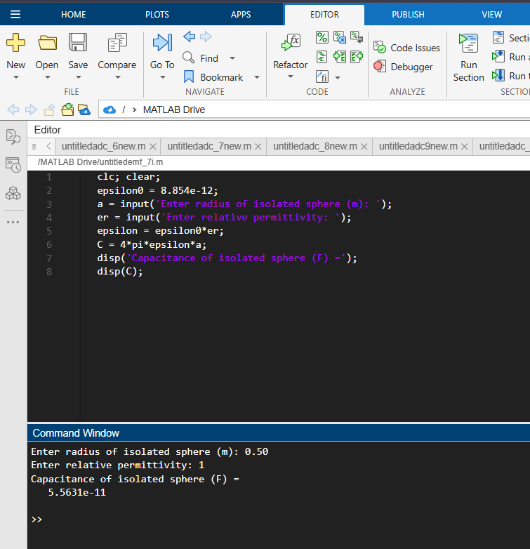
Test Case (ii) – Variation of Isolated-Sphere Capacitance with Radius
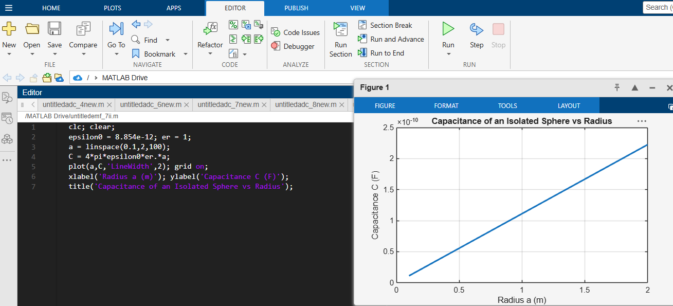
Test Case (iii) – Capacitance of a Concentric Spherical Capacitor
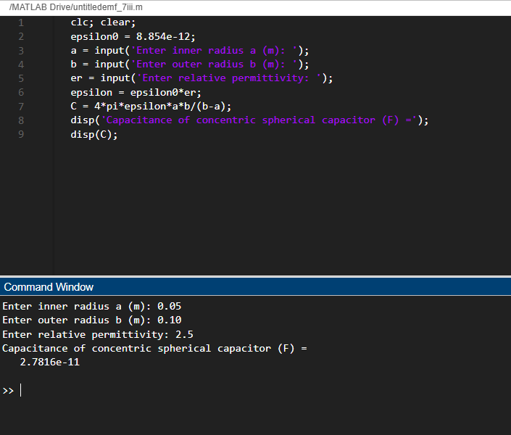
Test Case (iv) – Effect of Outer Radius and Relative Permittivity
